**Griffin Tech Innovations**

Solutions for Flix2You

SCS 230 75

Todd Price

April 20, 2023

Griffin Tech Innovations

1 Seton Hill Drive

Greensburg, PA 15601

**Griffin Tech Innovations Development Team**

Research, Writer/Editor: Jonah Zembower [j.zembower@setonhill.edu](mailto:j.zembower@setonhill.edu)

Programmer: Daniel Cavanaugh [d.cavanaugh@setonhill.edu](mailto:d.cavanaugh@setonhill.edu)

Graphic Artist: Jimmy Baxter [jp.baxter@setonhill.edu](mailto:jp.baxter@setonhill.edu)

Data Analyst: Niko Apodiakos [n.apodiakos@setonhill.edu](mailto:n.apodiakos@setonhill.edu)

**Table of Contents**

**Executive Summary**……………………………………………………………………………4

**Project Overview**………………………………………………………………………………5

Scope of Work…………………………………………………………………………..5

**Project Management**…………………………………………………………………………..7

Project Plan……………………………………………………………………………..7

Project Resources and Budget………………………………………………………….9

**User Analysis**………………………………………………………………………………….10

Users…………………………………………………………………………………...10

Database Access……………………………………………………………………….10

**Organization of Data**…………………………………………………………………………12

Identifying Relationships………………………………………………………………12

Normalization………………………………………………………………………….14

**Database Administration**…………………………………………………………………….16

Database Implementation………….…………………………………………………..16

Database Backup and Recovery……………………………………………………….17

Data Access and Security……………………………………………………………...18

Dataload……………………………………………………………………………….19

**Database Dashboard and Analytics**………………………………………………………...20

**Legal Issues**…………………………………………………………………………………..22

**List of References**……………………………………………………………………………24

1. **Executive Summary**

Flix2You is a company in the movie-viewing industry. This industry is competitive with organizations such as Netflix, Redbox, and Blockbuster. Technology is constantly evolving within the industry and requires up-to-date information to succeed in the competitive atmosphere. Flix2You is currently uncompetitive in the industry with outdated technology. However, with hopes of maximizing information reporting capabilities, Griffin Tech Innovations are creating an organized database system that utilizes the data efficiently from Flix2You.

Our team has a great reputation for working on many previous projects, whether large or small, that provide sustainable and efficient solutions within the industry. Our team encompasses a combination of talented programmers, writers, graphic artists, and analysts.

All of us at Griffin Tech Innovations are ecstatic about the opportunity to present our proposal to Flix2You’s management team and key stakeholders. We feel our proposal is impressive in its implementation, cost-effectiveness, and focus on the core deliverables for Flix2You. Our proposal will aid Flix2You in becoming a competitive member of the movie streaming industry. Our solution is plausible and flexible to be instituted within a reasonable time frame. We expect a high return on investment for the company and a greater focus on the ability to understand and appease consumers.

1. **Scope of Work**

The competition is increasingly growing in the movie streaming industry with organizations such as Netflix, Redbox, and Blockbuster. This is requiring speedy action for Flix2You to appropriately keep up with the competition. The latest market trends indicate that the DVD for movies is losing its value among consumers. Therefore, websites for movie purchases and online streaming are becoming more readily used and popular among consumers. For Flix2You to keep up with the competition and the vast growth of technology within the industry, it must adapt and expand its capabilities in this new landscape. Currently, there are a lot of issues that need to be addressed regarding the way data is collected, stored, and reported. Flix2You is currently struggling to accurately and swiftly report all necessary to develop actionable insights for appeasing consumers. Flix2You has switched to a fully-online approach to the industry while diving deeper into other areas of the industry, such as apps and games. However, since they cannot understand what they need to appeal to the consumers, they have started to peak in their ability to gain new customers while hitting a plateau. This is alarming but can be addressed. With the understanding we hope to provide from our proposed database system, we look forward to providing information that is accessible to the appropriate users and allow the company to receive actionable insights into enticing more customers to try their online ecosystem and movie streaming services.

Currently, Flix2You has employees involved in the necessary areas. They have 20 hourly employees working in the warehouse and logistics. This is a good ratio for all 50 employees. However, they don’t have great access to or understanding of the current database. Our goal is to improve their ability to handle the database. This will allow management to finally understand the information from the data for them to direct the company in the right direction effectively. We need to direct the database administration to ease end users' access, only reporting necessary information to particular users.

Our team recommends that a full-time Database Administrator is on staff, whether hired or appointed from within the company. This Database Administrator must be trained in MySQL, Oracle, and DB2 proficiently. The purpose of the Database Administrator is to manage the DBMS and ensure the database is functioning properly. The Database Administrator should be able to follow all steps outlined in this project, maintain privacy and security standards, perform server backups, and promote the sustainability of the DBMS through necessary updates and training for employees.

Furthermore, we propose to change the website's structure and allow for administrative viewing. We also recommend the implementation of an e-commerce website for consumers. How we depict user analysis capabilities and restrictions are addressed later in this proposal.

To accomplish all these objectives, we plan to implement a new database management software package. This will aid in the speed, protection, and backup of the data in the database. It should also meet the necessary attributes Flix2You wants, such as reporting and analysis, user-friendly dashboards, and proper queries. This software should withstand increased traffic loads due to the potential influx of consumers. Backup of data will be maintained on the cloud by the Database Administrator through Microsoft Azure and MS SQL Server 2022.

1. **Project Management**

**Project Timeline**

The timeline in this proposal is meant to be as flexible as possible. The goal is to provide the necessary time for implementation, debugging, testing, and any other necessary changes that arise along the way. We also plan to set aside time for employee training management. Overall, the timeline should be diligently followed to ensure that the project is instituted on schedule.

**Phase One: Analysis - Two Weeks**

During this phase, Griffin Tech Innovations will meet with Flix2You management and employees to discuss business rules and company goals. Afterward, our team will meet together to discuss future directives based on the ideas from the Flix2You company. We will overview ordering software and develop the new database design.

**Phase Two: Development - Two Weeks**

Using the determined business rules, we will revise the database tables. Then, code will be written and test data loaded. Queries will be written to test the new system, and data loaded and test reports will be generated from the queries. We planned extra time for any possible malfunctions that may occur. We intend to promote the reliability of the database through many testing trials in this phase to fix any problems then and prepare for problems in the future.

**Phase Three: Implementation - Three Weeks**

During the implementation phase, the hardware and software should be installed. The Flix2You accounts will be set up with Microsoft’s Azure and SQL. We will load the previous data from Flix2You into the new system, and it will be adjusted accordingly with a smooth transition for all employees. We will put in test queries that will run on data load to ensure proper reports can be expected to occur. Backup services through Microsoft Azure will be instituted. Then, we will test the integrity follows from the system. After this, we plan to test the entire system as a team to ensure that everything is implemented correctly and efficiently. The last week will be spent by Griffin Tech Innovations teaching training sessions to the necessary Flix2You management and employees to ensure a smooth transition for the new database system. The specific training sessions will be based on data integrity, including any necessary maintenance, creating reports, data entry, and ensuring system backup recovery is effective.

**Schedule/Chart**

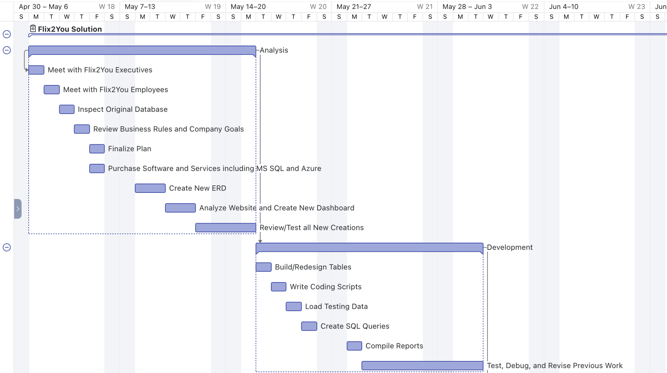

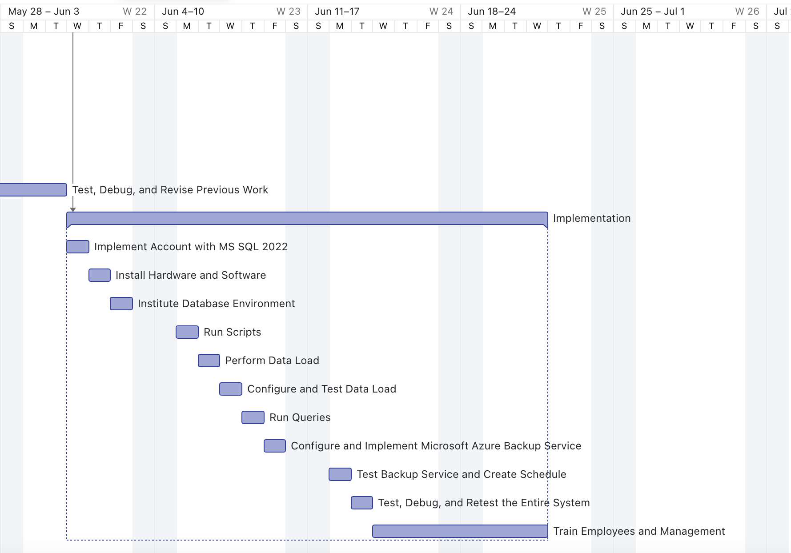

**Budget**

**Labor Budget**

|  |  |  |  |  |
| --- | --- | --- | --- | --- |
| **Name** | **Role** | **Cost** | **Projected Hours** | **Total Cost** |
| Jonah Zembower | Research, Writer/Editor | $37/hour | 280 hours | $10,360.00 |
| Daniel Cavanaugh | Programmer | $39/hour | 280 hours | $10,920.00 |
| Jimmy Baxter | Graphic Artist | $35/hour | 280 hours | $9,800.00 |
| Niko Apodiakos | Data Analyst | $39/hour | 280 hours | $10,920.00 |

**Supply Budget**

|  |  |  |  |  |
| --- | --- | --- | --- | --- |
| **Component/ Service** | **Details** | **Cost** | **Quantity** | **Total Cost** |
| Microsoft Azure | Cloud and Backup Storage |  |  | $16,122.00 per year |
| Microsoft SQL Server 2022 | Storage |  |  | $15,123 per year |
| Microsoft Power BI | Business Intelligence, Dashboard, and Analytics | $4,995 per month |  | $59,940 per year |
| HP ZBook Fury 17 G8 | CPU: Intel Xeon W-11955MGPU: Nvidia RTX A5000RAM: 64GBStorage: 1TB SSD Display: 17.3-inch UHD (3840 x 2160) | $3,025 | 10 | $30,250 |

|  |  |
| --- | --- |
| **Total Labor Budget** | $42,000 |
| **Total Supply Budget** | $121,435 |
| **Total Project Budget** | $163,435 |

1. **User Analysis**

Flix2You is comprised of several different departments that make up the company. Within each of these departments, there are many users that will require access to the database for specific areas to perform daily tasks. These users will require certain data amounts and sections more than others, and it should be adjusted accordingly to avoid overuse of the server. The appropriate tables and entities should be labeled for users to have access. Database access will be restricted to only the appropriate necessary tables or entities for most user groups. We want to ensure data integrity and privacy by preventing unapproved access.

The acknowledged user groups include the Database Administrator, System Administrator,

IT staff, Company Managers, HR department, Customer Service, Shipping, Billing,

Accounting, and the Advertising/Marketing department.

Database Administrator

The Database Administrator (DBA) has the highest level of access and privileges available. There are no restrictions on the Database Administrator for viewing, manipulating, or creating. This enables the administrator to create new entities while making changes to existing entities and data structures, drop existing entities, and grant additional privileges to those outside the

inner circle whenever necessary. Overall, the Database Administrator ensures consistency, security, and stability for the system by limiting the ability of other users to create and change tables and data structures.

System Administrator & IT staff

The System Administrator and IT staff members have tasks that will require system-wide access

similar to the level of access for the DBA. Furthemore, they have many of the same privileges that the Database Administrator does. This includes the ability to view and manipulate all data and entities. However, this set of users will not be able to create or eliminate entities for data integrity purposes.

Company Managers

Company managers have many of the same privileges as the previous System Administrator and IT staff user group, with a few exceptions. This group has access to all tables to view, insert, and change data in the database tables, but they won’t be able to create new entities or change the overall structure of the existing entities. Therefore, managers can execute all of their duties and responsibilities without endangering overall system functionality. This is due to the lack of experience in database technology.

HR Department / Customer Service/ Accounting

The HR, Customer Service, and Accounting Departments use customer and employee data. Similar to customer management, this user group is restricted from creating or eliminating entities and changing data structures. However, they will also have restricted access to viewing and manipulating tables. The HR and Accounting department will only have access to employee data to view and manipulate the data contained within employee tables, such as employee pay and hiring. Similarly, the Customer Service Department will only have access to Customer related entities and data made up of the following tables:

CUSTOMERS, CUSTOMER_RENTALS, and ACCOUNTS

Shipping & Billing

Shipping and Billing Departments do not have the ability to create or eliminate tables from the database, and viewing is restricted to specific tables that are of concern to each department. The Shipping department will have its views and editing privileges restricted to the following tables:

CUSTOMERS, CUSTOMER_RENTALS

The Billing department will have its views and editing privileges restricted to the

following tables:

CUSTOMERS, FINANCIAL_TRANSACTIONS, ACCOUNTS

Advertising & Marketing Departments

Advertising and Marketing Departments are restricted from creating or eliminating tables and may not alter data structure. Unlike the other user groups, these users are also restricted from editing any tables, leaving them with simple viewing privileges and only for a few select tables. This should be sufficient for the purposes of these departments, as their role is concerned more with interpreting data to use strategically for marketing and advertising to attract new customers. This user group will have to view privileges only for the following tables:

MOVIES, CUSTOMER_RENTALS, CUSTOMERS

Customers

Customers aren’t truly a set of database users because they have no privileges of any kind. They are included, however, because of their limited interaction with the database through the FLIX2YOU website by creating an account, entering personal information, and selecting movies from the available titles held in the database.

1. **Organization of Data**

New ERD

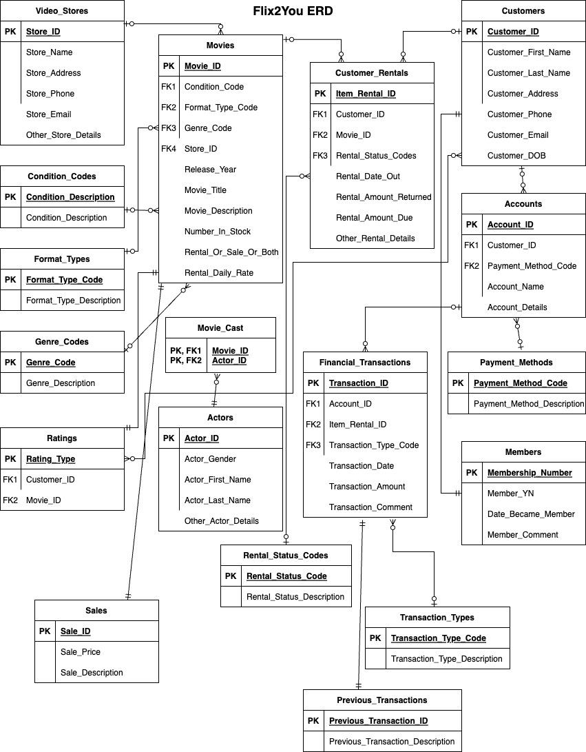

The initial Flix2You database produces unnecessary results. Griffin Tech Innovations developed a revised table structure in order to eliminate anomalies and redundancies. We hope it also updates to include all necessary functions for Flix2You to be competitive within the industry. We suggest updating the Flix2You table structure to the third normal form (3NF), which will produce much more desirable results.

Initially, the tables are in first normal form (1NF). After removing all partial dependencies, the tables are in second normal form (2NF). We decided to convert the Flix2You table structure from the second normal form to the third normal form by deleting all transitive dependencies within the tables.

The final design will remove any insertion, update, or deletion anomalies, which guarantees the integrity and consistency of the data. Flix2You will have a much more reliable and effective way to interact with their database.

**Normalization of Flix2You**

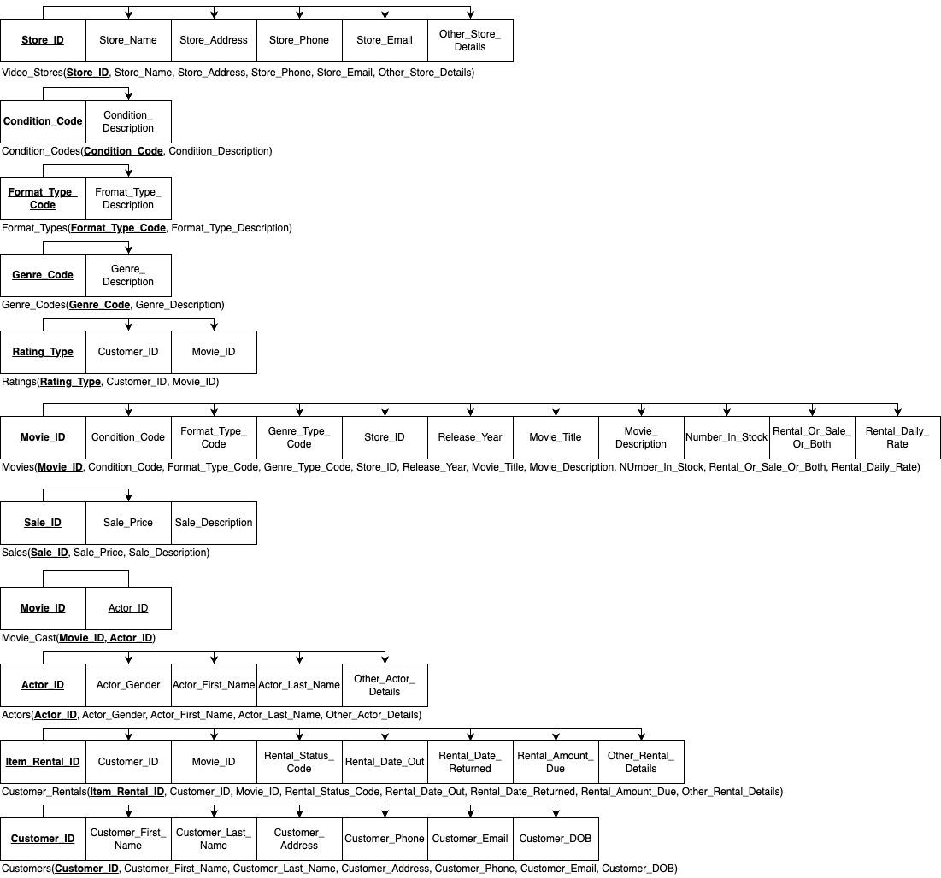

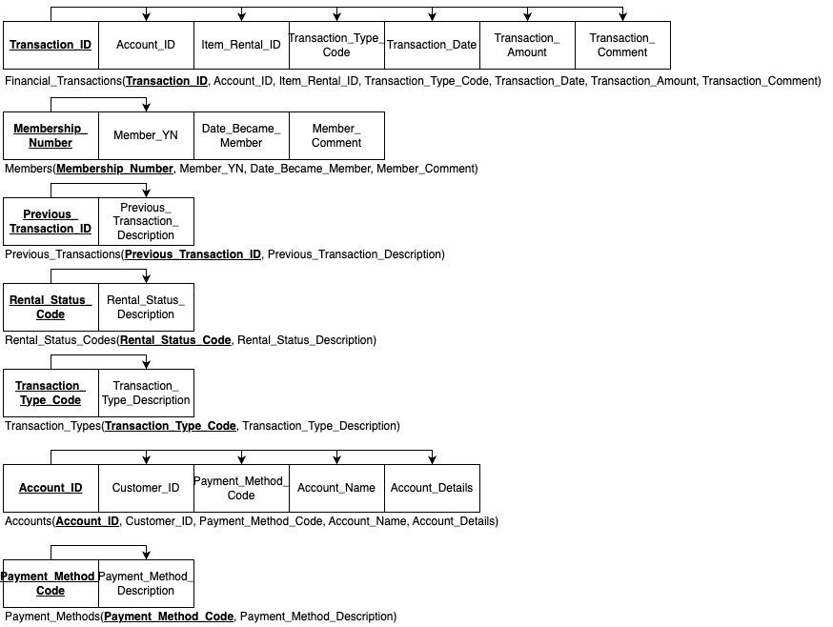

1. **Database Administration**

Flix2You’s Database Administrator (DBA) roles and responsibilities are distributed into two major sections within this proposal. The DBA should serve a major role during the implementation stage of the project with key decisions surrounding the Database, and the DBA will have daily roles and responsibilities once Flix2You is running within Microsoft SQL Server 2022. The following information details the knowledge and duties that the assigned DBA(s) will provide to effectively administer Flix2You’s database system and ensure a successful transition from Microsoft SQL Server 2008.

**Database Implementation**

The DBA has worked closely with the system administration team to help determine the database management system that will be used to manage and store Flix2You’s database(s). Also, the DBA has knowledge of the hardware and software needed for an efficient database server and ensures the applicability of Microsoft SQL Server 2022 for delivering the resources and storage needed during the deployment and implementation phases.

As detailed in the budget section of our proposal, the database will be installed and managed with Microsoft Azure cloud capability and stored through Microsoft SQL Server 2022. This should promote data fluency. The database server will be installed on portable computers and access to other locations through Microsoft Azure. Furthermore, continuing with Microsoft products saves time with the migration from the existing database server and implementation to the new Microsoft SQL Server 2022.

Griffin Tech Innovations comprised a schedule that should avoid overtaxing the schedule of current Flix2You employees and their daily tasks. The DBA will move the existing database to Microsoft SQL Server 2022 and make a backup of the existing database on the Friday night before the scheduled cut-over from the old system/platform and copy them to the new database server. On Saturday morning, the DBA will load the copied full backup (SQL files) taken Friday night (existing Flix2You database) and then restore the database on the new Microsoft Azure cloud. After the database has been restored to the new platform, the DBA will test the integrity of the data and ensure that the data was successfully restored. The DBA will troubleshoot and resolve any issues regarding the restoration of Flix2You’s existing data on the new platform and ensure that the database is ready for its live usage.

**Database Backup and Recovery**

Flix2You’s database backup and recovery plan has three factors. First, we address Flix2You’s backup and recovery plan by ensuring that we have a capable and secure storage location to place our database backups. As Fix2You’s business and customers begin to grow and expand, we are able to expand and grow our database storage and backup locations to compensate for the growth in the cost-effective Microsoft SQL Server 2022. This server will also provide our system with increased software and physical and environmental security. The DBA will also monitor the storage situation as part of their daily, weekly, and monthly role.

Secondly, within Microsoft SQL Server 2022, we will schedule a full-backup job to run every morning at 2:00 AM ET, with the output being stored on the storage server. Flix2You’s business units will mainly access the database during a 9 AM to 5 PM work day and our peak usage for our customers is between 6:00 PM to 11:00 PM, typically for each time zone. In addition to a full daily backup of the database, we will create a daily transaction log backup job to run every two hours, starting at 6:00 AM ET and ending at 12:00 midnight ET.

Our last phase in our database backup is the recovery plan. In addition to taking backups of our database, we will take daily backups of our Microsoft Azure location(s) and copies of our Microsoft SQL database server. These locations are where our database backup files and logs are stored and having a copy of the actual database server allows us the option to quickly restore the whole database server along with the database. This gives us a last resort for occurrences of failure in the initial backup process to ensure data security and privacy.

Overall, the backup and recovery plan is part of the DBA’s daily job duties. They will monitor the maintenance and backup jobs throughout the day to ensure that maintenance and backup jobs are executing as expected without errors. The DBA will also validate in the morning that the 2:00 AM ET backup job is executed as scheduled. If recovery of the database or database server is ever required, the DBA will work closely with the system administrator to ensure full operation recovery of the database and system.

**Data Access and Security, Privacy Statement**

Flix2You’s assets will be secured by a team approach divided into three different levels

of access, managed by four different teams. Since Flix2You’s business is web-based

and accessed through the internet and mobile devices; the database administrator has

to work with the system administrator, network administrator, and webmaster to ensure

that the integrity of the database is not compromised. Therefore, the database

administrator has worked closely with these teams to ensure that we have

website/network security, system security, and database security. The following is a

brief description of each of the levels of security provided, with the database being the

core system that we want to insulate from potential threats. It all starts with

website/network security, then system security, and ends with database security.

**Website/Network Security**

Flix2You’s website is what drives revenues for the company and allows customers the opportunity to use its services. Since the website is essentially the most seen part of Flix2You, it needs to be accommodating, inviting, and welcoming for new customers. With making Flix2You’s web servers accessible to the entire world via the world wide web; the webmaster, network administrator, and system administrator have taken care of this level of security with tight customer user permissions (unique customer IDs/usernames and password requirements), ensuring that the website is coded with advanced and highly secured standards, and ensuring that the web servers, web applications, and network components are frequently updated with the most recent security patches. We will employ strategically placed Firewalls within the network infrastructure, use intrusion detection software and use encryption where applicable. The main purpose of these policies and actions is to secure Flix2You’s website, limiting the potential for the website to be hacked, which would then cause the data in the database to be compromised. These policies also help protect our internal users and employees from allowing an attack to happen internally within Flix2You. Assets are projected from outside and inside the organization.

**System Security**

Flix2You’s web servers, storage servers, database servers, and workstations run on Windows-based operating systems. Flix2You utilizes a domain controller and uses Microsoft Windows Active Directory with Group Policies to manage internal access to the applications and the systems used by employees, IT personnel, and management. Referencing our “user analysis” section of this proposal, direct access to our database server, web server, storage server and the database itself will be limited to the administrators’ group. Customers do not have any direct access or credentials to access any of the above systems.

**Database Security**

As outlined in our “user analysis” section of this proposal and diagram, only a select group of users will have direct access to read/write capability in our database. Customers will have no direct access to the database or database server. This is also true for various internal groups of employees/users. In addition, only the Database Administrators, analysts, and System Administrators will have a username and password to log in to the database server. The database administrators, along with the system administrator, will monitor the logs of the database server on a daily basis to ensure that critical patches and updates are made to the RDBMS and to the operating system of the database server. Updates from Microsoft should run daily on the database server, so it should be updated frequently with any security patches released. This, along with limiting permission and rights access to the database, will help keep it insulated from outside attacks and from being viewed or updated by unintended users.

**Privacy Statement**

Flix2you has always taken customer privacy seriously and will continue this policy as we switch to our new platform. Our detailed customer privacy statement is located on our website and can easily be accessed from any page on the website. The full privacy statement is also located and detailed under legal issues. In addition, our website contains legal and copyright information that explains to our customers that our employees have access to their personal information, including name, address, date of birth, and credit card information. For the employees that have access to customer information, we perform background checks, fingerprint them, and require them to sign disclosures stating that they will not use customer or company data inappropriately. Employees are also held to Federal, State, and local laws and regulations as well.

**Data load**

Our migration plan is outlined above and has been scheduled to take place during a time that will have minimal impact on Flix2You customers and employees. We will use the built-in utility in Microsoft SQL Server 2022 if the need arises to import or export large amounts of data into or out of our operational database. We can also utilize the SQL Server Import and Export Wizard to import or export various data sources, including Oracle, Access, an Excel spreadsheet, etc.

1. **Database Dashboard and Analytics**

The Griffin Tech Innovations team will be creating a Data Mart with new tables that have specific entities and attributes designed to report the data needed for the dashboards. We will run a nightly ETL process that will pull data from our Operational Database into the Data Mart staging tables. We will also work on creating meaningful mobile reporting tools.

In order to have a successful on-time launch of Power BI, the BI team will work concurrently with the DBA teams with the following timeline:

2 Weeks: Analyze Gathering business rules and data requirements from management

and SMEs. Establish a timeline for full implementation.

2 Weeks: Design and build. We will install a development environment to design, build

and test the reports and dashboards.

3 Weeks: Deploy and Operate. Once report functionality has been thoroughly tested, we

will load all production data into Power BI and train users.

Power BI offers real-time dashboard data that gives useful insights to users. Our goal is to separate the users based on their necessity of task with the appropriate data tracks on their specific dashboard.

To populate the Power BI dashboard, Griffin Tech Innovations will create these transactional database tables.

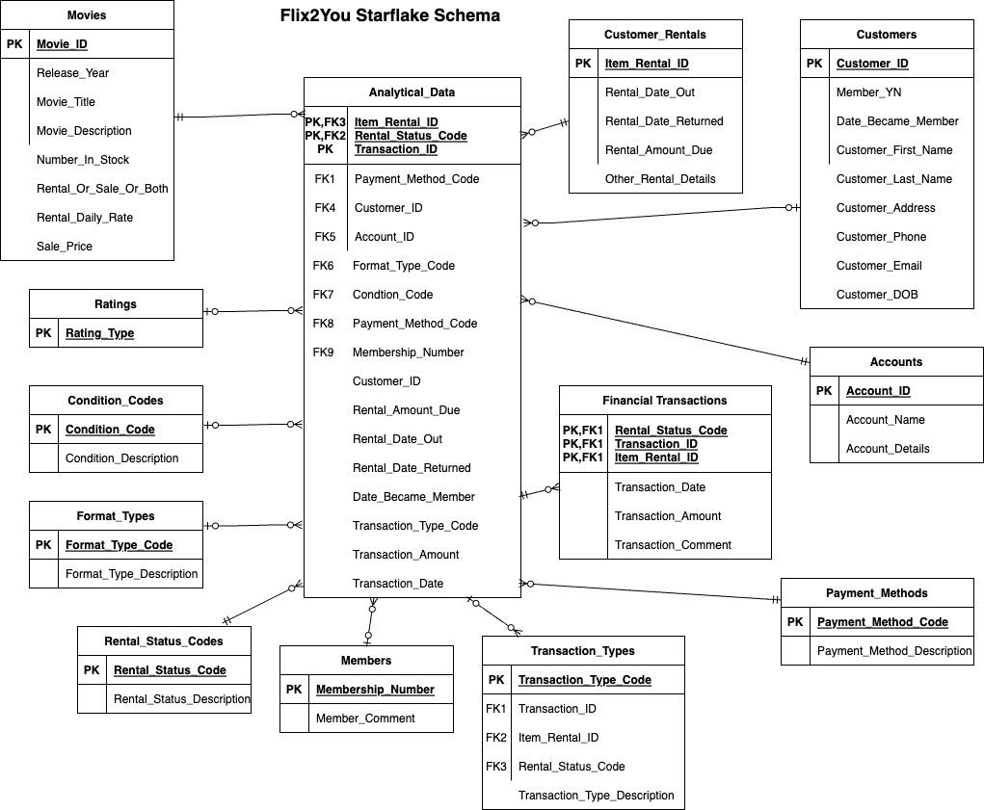

1. **Legal Issues**

The following sections include the privacy policy and privacy statements of Flix2You which can be found on Flix2You’s website. These statements have been approved for use by our legal team.

**Privacy Policy**

This Privacy Policy explains our policy regarding the collection, use, disclosure, and transfer of your information by the Flix2You family of companies. To learn which company is responsible for processing your personal information and for instructions on how to contact us, please see the “International Users/Contacting Us” section below. By using, visiting, or browsing the Flix2You service, you accept and agree to our information practices described below. Please note that this Privacy Policy includes embedded hyperlinks that may only be accessed through our website, so if you are reviewing this Privacy Policy through certain Flix2You ready devices (for example, game consoles or Internet-enabled televisions), you may need to visit the website to review these hyperlinked terms.

• Collection and Use of Information

This includes any personal information about you and your use of the service.

• Disclosure of Personal Information

Flix2You may share your personal information within the Flix2You family of companies.

• Social Sharing

You may elect to share information about your use of the Flix2You service, including

what you watch within Flix2You as well as on other social networks and in other

communications.

• Other Websites, Platforms, and Applications

The Flix2You service may be provided through platforms or contain links to sites

operated by third parties whose policies regarding the handling of information may differ

from ours.

• Children

You must be 18 years of age or older to subscribe to the Flix2You service.

• Right to Access Your Information

We give you access and the ability to update a broad range of information about your

account, including your contact information and your communication preferences in the profile portion of our website.

• Cookies and Internet Advertising

Visit About Cookies and Internet Advertising (https://www.Flix2You.com/cookies) for information about our use of cookies, other technologies, and Internet advertising.

• Security

Flix2You takes information security seriously and uses reasonable administrative,

technical, physical, and managerial measures to protect your personal information from

unauthorized access.

• Changes to This Policy

Flix2You may occasionally make changes to this Privacy Policy, the Social Terms or About Cookies, and Internet Advertising.

• Transfer of Information

Given that the Internet is a global environment, using the Internet to collect and process information necessarily involves the transmission of data on an international basis.

**Terms and Conditions for Use**

We at Flix2You try to have your best interests in mind. When a movie is purchased, there should be instant gratification through our online streaming service. However, if you experience any disruptions, call our help number at the bottom of the front page of the website to assess the problem. If this problem seems to persist. We have a strict refund policy. This ensures that you, the customer, are receiving the best experience from our products. Our refund policy ensures that you will have the ability to purchase something again after the issue is solved.

Furthermore, consequences may be involved if any condition from the privacy policy above is violated by the customer or employee. This may result in a ban from purchasing products from the family of Flix2You or another penalty, depending on the severity of the dilemma. We hope to avoid any security breaches with the proper implementation of security protocols. However, those that attempt to breach secure company data may be penalized by the government and prosecuted by the Flix2You company. All other non-related issues may be dealt with accordingly as seen fit by the administration of Flix2You and the legal staff.

References

Microsoft. (2023). *What is Power Bi? Definition and features: Microsoft power bi*. Retrieved

April 18, 2023, from https://powerbi.microsoft.com/en-us/what-is-power-bi/

MS SQL Tips. (2023). *SQL Server tools*. SQL Server Products and Tools. Retrieved April 18,

2023, from https://www.mssqltips.com/sql-server-tools/

Netflix. (2022, November 1). *Privacy statement*. Netflix Help Center. Retrieved April 18, 2023,

from https://help.netflix.com/legal/privacy

*SQL Server 2022.* (2022). Microsoft. Retrieved April 16, 2023, from

https://www.microsoft.com/en-us/sql-server/sql-server-2022

*What Is Azure-Microsoft Cloud Services | Microsoft Azure.* (2023). Microsoft. Retrieved April

16, 2023, from https://azure.microsoft.com/en-us/resources/cloud-computing-dictionary/what-is-azure/?&ef_id=_k_CjwKCAjwue6hBhBVEiwA9YTx8Oip63PUXOLg6_A7smXC6c44IjYNLLL2k5f0e4gp-AScXAbbCDOK4xoCdxYQAvD_BwE_k_&OCID=AIDcmm5edswduu_SEM__k_CjwKCAjwue6hBhBVEiwA9YTx8Oip63PUXOLg6_A7smXC6c44IjYNLLL2k5f0e4gp-AScXAbbCDOK4xoCdxYQAvD_BwE_k_&gclid=CjwKCAjwue6hBhBVEiwA9YTx8Oip63PUXOLg6_A7smXC6c44IjYNLLL2k5f0e4gp-AScXAbbCDOK4xoCdxYQAvD_BwE